**CLUSTER**

With Amazon ECS, you can create a cluster by defining a cluster configuration, which includes the number of instances, instance type, and other parameters. You can then register EC2 instances to the cluster using the ECS agent, and deploy containerizedapplications to the cluster.

With Amazon EKS, you can create a Kubernetes cluster by defining a cluster configuration, which includes the number of instances, instance type, and other parameters. You can then launch worker nodes in your AWS account and register them with your cluster using the Kubernetes API.

Both ECS and EKS offer several benefits for running containerized applications in AWS, including automatic scaling, high availability, and security. You can use other AWS services, such as AWS Fargate, AWS CloudFormation, and AWS CloudWatch, to further automate and manage your containerized applications in the cluster.

To create an AWS cluster, you need to have an AWS account and navigate to the ECS or EKS console in the AWS Management Console. From there, you can create a cluster and configure it according to your requirements. You can also use the AWS CLI or AWS SDKs to create and manage clusters programmatically.

Step 1:AWS Configure

The "aws configure" command is used to set up and configure the AWS Command Line Interface (CLI) on your local machine. This command will prompt you to enter your AWS access key ID, secret access key, default region name, and default output format.

Here are the steps to use the "aws configure" command:

* Open your gitbash
* Type "aws configure" and press Enter.
* Enter your AWS access key ID when prompted.
* Enter your AWS secret access key when prompted.
* Enter your default region name (e.g. us-west-2) when prompted.
* Enter your default output format (e.g. json) when prompted.

Once you have completed the configuration process, you will be able to use the AWS CLI to interact with AWS services from your local machine.

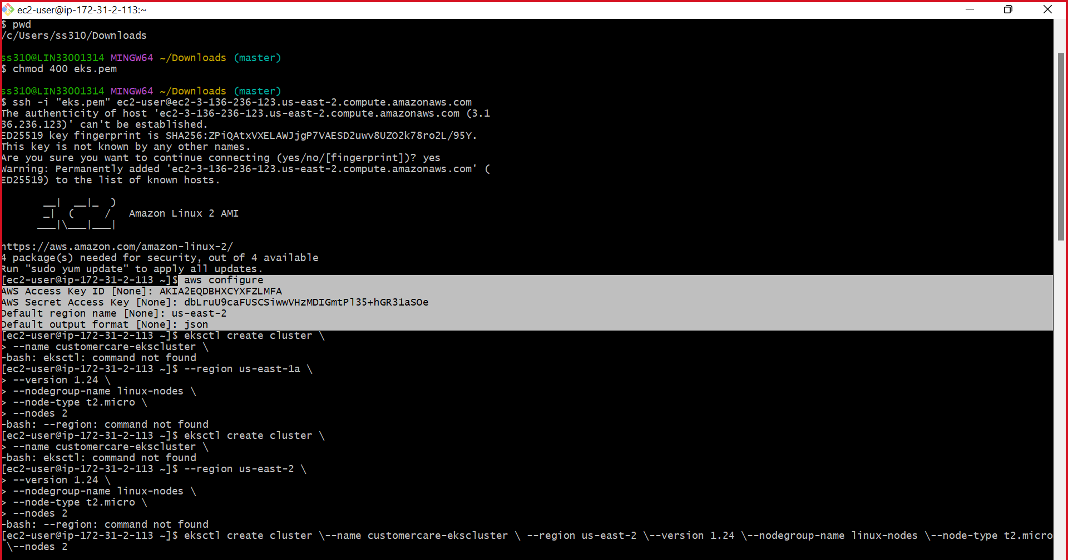

Step 2: Installing eksctl

Eksctl is a command-line tool for creating, managing, and operating Kubernetes clusters on Amazon Elastic Kubernetes Service (EKS). It simplifies the process of creating and managing Kubernetes clusters by automating many of the tasks involved.

Here are some of the tasks that can be performed with eksctl:

* Creating a new EKS cluster with a single command.
* Managing worker nodes and their associated resources, such as security groups and auto-scaling groups.
* Upgrading an EKS cluster to a newer version of Kubernetes.
* Adding or removing nodes from an EKS cluster.
* Configuring Kubernetes add-ons, such as the Kubernetes Dashboard or the Cluster Autoscaler.

which allows you to manage your EKS resources as a stack of AWS resources, making it easy to deploy, scale, and manage your clusters with ease.

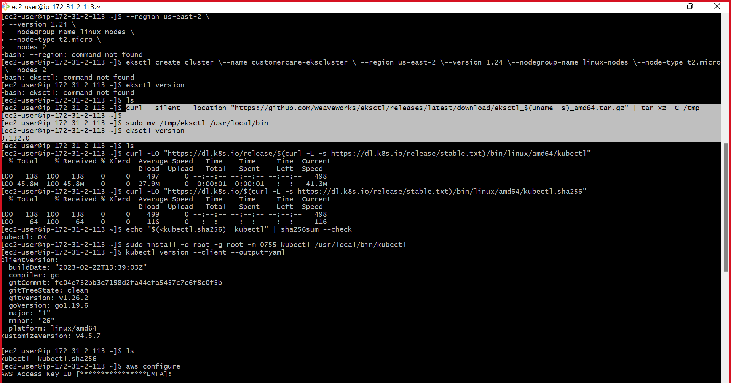

Step 3: Installing kubectl

Kubectl is a command-line tool for managing Kubernetes clusters. It allows users to interact with Kubernetes clusters by sending API requests to the Kubernetes API server.

Here are some common tasks that can be performed with kubectl:

* Deploying applications to a Kubernetes cluster by creating Kubernetes objects, such as Pods, Deployments, Services, and ConfigMaps.
* Inspecting the current state of Kubernetes objects by running commands like "kubectl get pods" or "kubectl describe deployment".
* Scaling up or down the number of replicas for a deployment using the "kubectl scale" command.
* Rolling out updates to a deployment using the "kubectl rollout" command.
* Executing commands in a container running in a Pod using the "kubectl exec" command.
* Debugging issues by inspecting container logs using the "kubectl logs" command.

Kubectl can be installed on your local machine or in your CI/CD pipeline, and it can be used to manage Kubernetes clusters running on any cloud provider or on-premises data center. Kubectl uses a configuration file to authenticate with the Kubernetes API server, and this configuration file can be generated by tools like eksctl, kops, or the AWS Management Console.

To install kubectl on your local machine, follow these steps:

1. Download the kubectl binary from the Kubernetes release page using the following command:

* curl -LO [https://dl.k8s.io/release/$(curl -L -s https://dl.k8s.io/release/stable.txt)/bin/$(uname | tr '[:upper:]' '[:lower:]')/amd64/kubectl](https://dl.k8s.io/release/$(curl%20-L%20-s%20https://dl.k8s.io/release/stable.txt)/bin/$(uname%20|%20tr%20'%5b:upper:%5d'%20'%5b:lower:%5d')/amd64/kubectl)

This command will download the latest stable version of kubectl for your operating system.

1. Verify the integrity of the downloaded binary by running the following command:

curl -LO [https://dl.k8s.io/release/$(curl -L -s https://dl.k8s.io/release/stable.txt)/bin/$(uname | tr '[:upper:]' '[:lower:]')/amd64/kubectl.sha256](https://dl.k8s.io/release/$(curl%20-L%20-s%20https://dl.k8s.io/release/stable.txt)/bin/$(uname%20|%20tr%20'%5b:upper:%5d'%20'%5b:lower:%5d')/amd64/kubectl.sha256)

sha256sum -c kubectl.sha256

This command will compare the SHA256 checksum of the downloaded binary with the expected value.

1. Make the kubectl binary executable by running the following command:

chmod +x kubectl

1. Move the kubectl binary to a directory in your PATH, such as /usr/local/bin, by running the following command:

sudo mv kubectl /usr/local/bin/

1. Verify the installation by running the following command:

kubectl version --client

1. 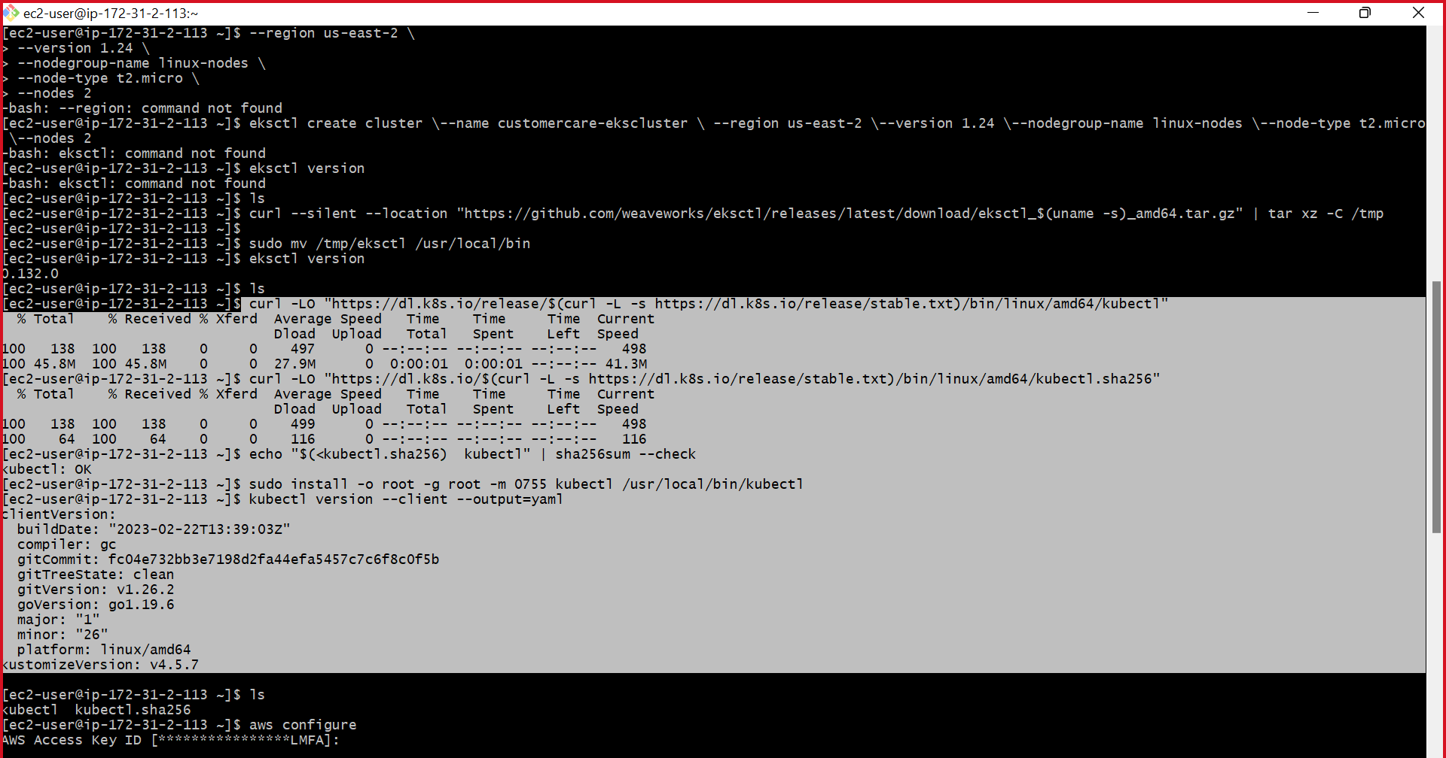

Step 4: Creating cluster

